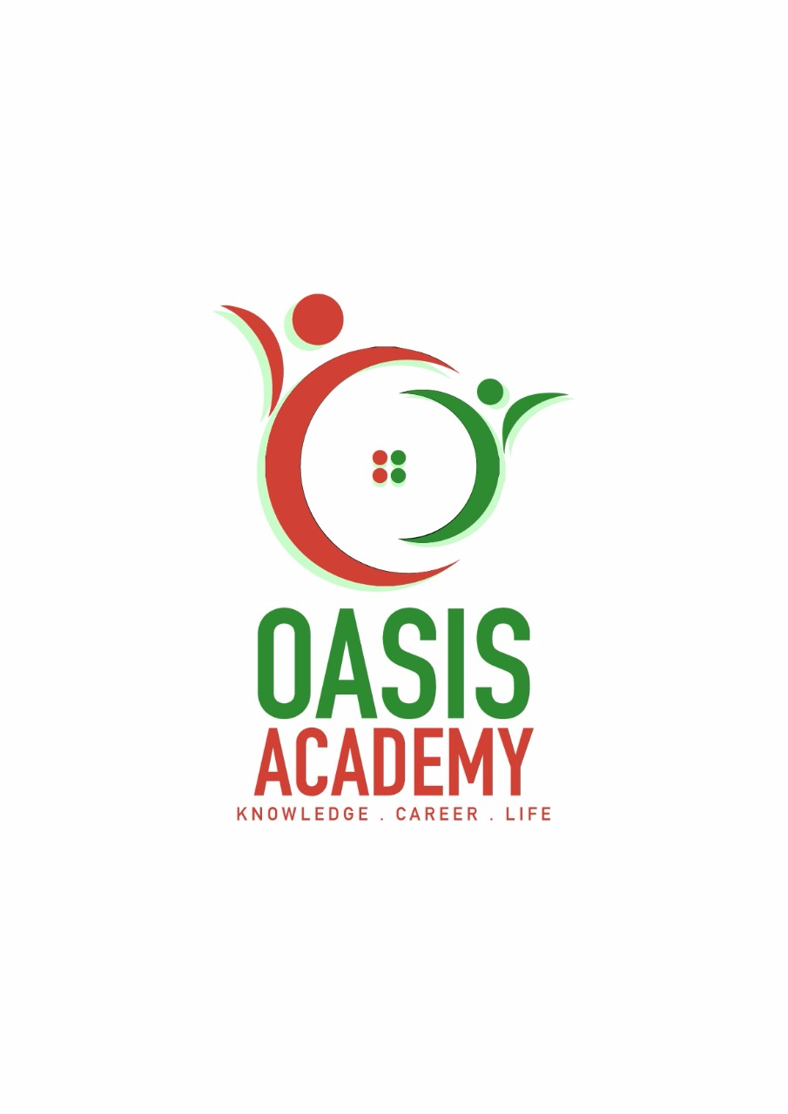

Name : Navin Raj Vijeyaindran

Login ID : navinraj@oasis-portal.com

Course Tittle : TOURISM AND HOSPITALITY

Subject Code : BHM 04

Submitted date;11 September 2017

**Table of Contents**

|  |  |  |
| --- | --- | --- |
| No | Details | Page |
| 1 | Executive Summary | 2 |
| 2 | INTRODUCTION | 3 |
| 3 |  |  |
|  | Question 1 | 4-9 |
|  | Question 2 | 10-15 |
|  | Question 3 | 16-21 |
|  | Question 4 | 22-24 |
| 4 | Conclusion | 24-25 |
| 5 | References | 26 |

**EXCUTIVE SUMMARY**

In this module, I have covered the topic about The Tourism and Hospitality. The purpose of this unit is to be able to understand the Tourism and Hospitality better as well as knowing the essentials in Business and Hospitality Operations. In the beginning of this, we can see the introduction of the Tourism and Hospitality. In this part, I have explained what is tourism and and what is hospitality. Next, in the second part I have briefed about nine types of tourism categories with a short definition for the each of the tourism categories. In the part, I have studied and described about the lodging accommodation. Besides that I have also given five types of hotel accommodation and its explanation for each hotel too. Last but not least, in the last part of this question I have explain a little about the significant of entertainment in this tourism and hospitality industry. In this module, I have briefed about what entertain center, where is it located, and how it is. I have also given five types of entertainment places and three points for each places.

1

**INTRODUCTION**

The Hospitality and Tourism Industry and encompasses lodging like at hotels, motels, resort it’s a most attractive places travel and tourism, recreation, amusement, resorts, restaurants, food and beverage services. Its a very important and the service all need that. Tourism is a field which offers so many jobs all around the world and with higher positions n higher salary in this field.

2

QUESTION 1

Define the Tourism and Hospitality

*Explain your understanding about Hospitality industry.

“The hospitality industry is a broad category of fields within service industry that includes lodging, event planning, theme parks, transportation cruise line, and additional fields within the tourism industry”

The industry of providing customer service to travelers or strangers. Hospitality professionals generally work in administrative or management positions in service-based environment, and there will responsible for overseeing the operation and success of an establishment, example such as hotels, motel and restaurants. The hospitality and tourism industry is diverse, and includes many locations including RV parks, food establishment, recreational facilities, boarding houses, and hostels for teenagers, while the overall goal of a hospitality professional is to ensure that guests and customers have pleasurable experiences, they can also be responsible for operation, such as hiring training new staff; supervising office and financial administration, housekeeping maintenance, and security staff and marketing.

Hospitality also distribute funds, set room rates, and ensure that the service standards of the business are met, generally duties for hospitality professionals depending on the size of the business and the amount of staff available. In larger operations, there is usually a hierarchy of general managers, assistant managers and super visior who work to perform operational tasks relating of their area. In a smaller business, the hospitality perform these tasks directly. Sometimes hospitality professional positions are specialized, for example some focus on managing the front office, customer, guest and strangers. If a hospitality professional is employed in specialized position, he or she must good in communication skills with ability to work alongside coworkers in other areas of the business.

Employers prefer applicants with a bachelor’s degree in business or hotel or hospitality experience may also be acceptable. Smaller establishments may accept applicants with a certifier or associate’s in hotel, hospitality or restaurant management.

4

MEANING OF HOSPITALITY;

➢ Refers to the relationship between a guest and a host, wherein the host receives the guest with goodwill.

➢ Welcoming behavior towards guests or people you just met.

➢ Serve or provides food drink and other priveleges which some companies provide.

➢ The virtue which include us to feed and lodge certain persons.

MEANING OF TOURISM;

*generic term, to cover both demand and supply that has been adopted in various forms.

*is the activity travelling from a to another

*staying outside from comfort zone

*is the business which provide people on holiday example hotel

*its also helps for people improve their business in tourism sector.

 5

***QUESTION 2***

***BRIEF ON DIFFERENT TYPE OF TOURISM CATEGORIES***

LEISURE TOURISM

CULTURAL TOURISM

RELIGIOUS TOURISM

FAMILY TOURISM

HEALTH TOURISM

SPORTS TOURISM

EDUCATIONAL TOURISM

BUSINESS TOURISM

6

***LEISURE TOURISM***

Tourists may travel to experience a change in climate and place and learn something new, enjoy pleasant scenery, or to know more about the culture of the place. Tourists, who seek break from the stress of day to day life, devote their holiday to rest and relaxation, refresh themselves. On this generation, tourists undertake various adventure sports activities for leisure and to refresh themselves after working hard. This tourism includes following forms based on the activities undertaken.

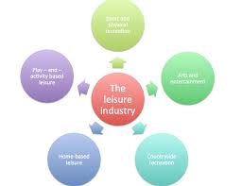

***CULTURAL TOURISM***

It is also called as heritage tourism. People are curious to know about foreign lands and their cultures. Culture is most important factors which attracts tourists to a destination. Its make more interesting to the visitors cause they can learn about others culture.

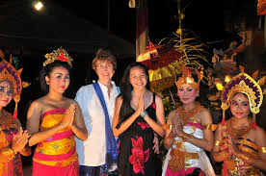

Foreigners learn culture.

RELIGIOUS TOURISM

Religious Tourism likewise regularly alluded as confidence or a faith tourism.

It is a kind of tourism, where individuals travel separately or in bunches for journey,

evangelist or recreation purposes.

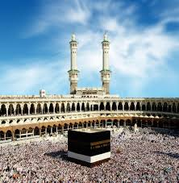

FAMILY TOURISM

Family Tourism includes the family and their investment in various type of tourism

action.

This tourism includes visiting one’s relatives or friends for interpersonal reasons.

By visiting one’s family and friends they can build a strange bond between each and other.

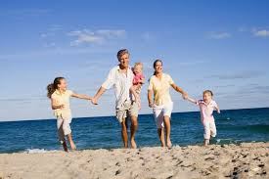

HEALTH TOURISM

Health Tourism are referred as medical tourism, usually people travels from a country to another country to obtain medical treatment.

Medical treatment must often is for cosmetic surgeries, dental surgery or for fertility surgeries.

This medical tourism is an age old concept that has gained popularity in the recent

times. Many developing countries are emerging as hot medical tourism destinations capitalizing on low cost advantages.

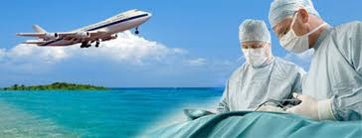

SPORTS TOURISM

Sports Tourism usually refers to an individual or a group of people who travels from their from their usual place to another new place which involves either observing or participating in a sporting event.

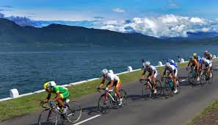

EDUCATIONAL TOURISM

Educational Tourism refers to a program in which tourist travels to a different places

as individually or as a group with a primary purpose of learning or going about new places and also the surrounding environment. In educational tourism, the main focus of the tour visiting another country to learn about the culture, such as in Student Exchange Programs and Study Tours, organizing specialized lectures of the eminent personalities and for research.

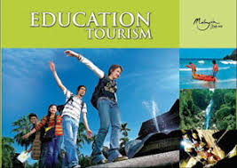

Business Tourism

Business Tourism can be also referred as business travel.

During business tourism, an individual is still working and being paid but they are just doing it away from both their workplace and home.

The purpose of business traveling is for attending meeting, conference and exhibitions in outside places from their usual working environment.

Business tourism is popularly called as MICE which stands for meeting, incentives, conferences and exhibitions respectively.



**QUESTION 3**

**DESCRIBE THE LODGING ACCOMODATION AND TYPES OF HOTEL ACCOMODATION.**

**VILLA**

Villa is a house, which usually in the countryside or near the sea, especially in Southern Europe, and often one that people can rent a villa for enjoy their holiday. Villa get down around quite a bit these days, but what exactly qualifies a certain dealing to be.

***HISTORY***

Originally, villa’s were in luxurious country estates that Roman noble would escape to from their day to lives in the city. the were like wealthy villages-built on ground scale, and often with expensive landscaping and vineyards. Roman Emperor Hadrian’s villa in Tripoli is perhaps the most famous of these, with its grand architecture and beautiful gardens. It is now of course reduced to ruins but even in that condition, the opulent nature of the estate is still impressive.

***TODAY***

Today, when someone talking about a villa, they are mostly like referring to a private luxury residence that is rented or bought as seasonal vacation home. The more private and intimate setting is attractive to traveller, because often, a villa includes similar services to that of a hotel, like breakfast, concierge, and cleaning services without the uneasy feeling that you are guest.

***Luxury villa’s often include the following;***

* 1 – 20 bedrooms in a villa

* Lush and manicured gardens, and vineyards.
* Some sort of water fixture, whether it to be pool or a fountain or both
* Terraces or balconies with view
* Elegant – furnishing and appliance

***SOME PICTURES OF LUXURY VILLA***

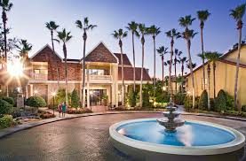

*VILLA WITH MOST ATTRACTIVE ARCHITECHTURE*

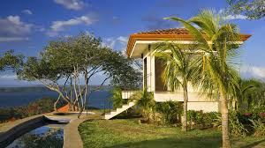*SEASIDE LUXURY VILLA*

**RESORT**

The origin of resorts can be traced back to the second century B.C. to the public baths of Rome. The first baths were small, modest and separated the genders. Eventually, the baths became larger, more elaborate and were opened to both men and women. These baths were large buildings built at the public’s expense. Some were even built by wealthy emperors who wanted to make a statement. Most baths were free but few had small entrance fees. Baths were much like resorts of today because of all the amenities offered at their location. After bathing there was always plenty to do. Most baths included gyms, libraries, snack bars, restaurants, shops, lounges, taverns, museums and theatres. The facilities were used for health and social purposes

The Swiss resort industry was developed in the 1800s to aid the need of private resort facilities for more prosperous people. At the time, travel was not simple. People who traveled to resorts stayed for long periods of time – up to two months to get the best value for their travel expenses. This led to resort facilities being built to accommodate a guest better than your average inn. Hotel Baur au Lac, built in Zurich, was the first resort to utilize the value of a scenic view. At first, Switzerland resorts were seen as summer places, but soon skiing became popular as well as gambling.

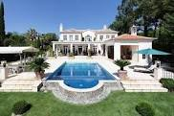

**Guesthouse**

Guesthouse is lodging which looks similar to a hostel, bed and breakfast or inn. Guest house are also inexpensive lodging. Guesthouse is a private home which have been converted into a guest accommodation as a form of lodging business by the owner. This type of accommodation presents some benefits like getting personalize attention and a healthy home.

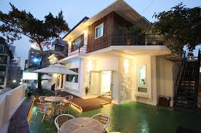

**Hostel**

Hostel is a place where provides food and comfortable. Lodging accommodations for a specific group of people, such as students, workers and travelers. It save money.

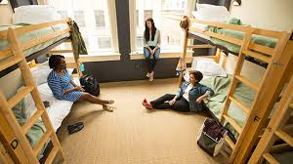

**Penthouse**

A penthouse is an apartment on the most astounding floor of a condo building or a lodging. Penthouse are ordinarily separated from different flats by extravagance highlights.

Penthouse can be also referred to as separate smaller ‘house’ that was built on the top of a loft building.

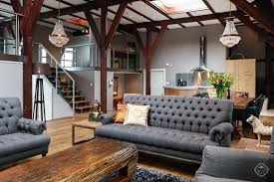

**Question 4**

Explain the significant of entertainment in this industry.

Entertainment is a form of activities which are able to take away one’s stress and replaced them with a proper amusement to relax. In tourism industry, entertainment is one of the important sector. Most tourist from outside countries, who comes for a vacation or holiday prefers to visit entertainment centers, cruise center, nightclubs and bars.

Five types of entertainment center’s activities which can elevate your experience when it comes to entertainment and few points for each of the entertainment center.

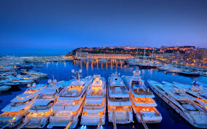

1)Marinas

Marinas are the most popular places to go if it comes to partying.

At this place you can get along well with your family, friends or relatives on a private yacht



2)Sports and gaming

Sports are an activity that involves physical exertion and skill in which an individual or team competes against another or other for entertainment. Gaming are a form of competitive activity or sport played according to rules. Sports and gaming are an entertainment where most tourists looks for because these kinds of activities could make them more relaxed.

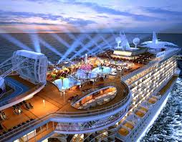

3)Cruise

Cruise services are also becoming an essential component of the hospitality industry.

Most people prefers to spend their days on luxury ships which sails across blue oceans and clear skies.

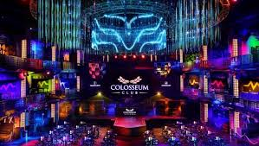

4)Nightclubs

Nightclubs is a place for a group of people to enjoy their night by drinking and dancing with their friends for an enjoyment and relaxation.

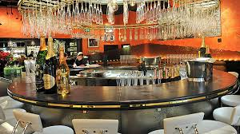

5)Bars

Bars are the main place for an entertainment center. Here everyone can sit and have fun with a couple of drinks with their loved ones.

**Conclusion**

In this assignment, I know a lot about The Tourism and Hospitality Industry knowledge and the overall operation of its importance. In the first question, I have the definitions for both of the tourism and hospitality industry. I have also brief a little of my understanding about this Tourism and Hospitality Industry.

Next, in the second question, I have explained nine types of tourism which has been categorized as leisure tourism, cultural tourism, educational tourism, business tourism and alternate form of tourism. In the third question, I have describe about the lodging accommodation and five types of the hotel accommodation Lastly, Tourism and Hospitality Industry’s important sector is an Entertainment Center for tourists who comes for a vacation or holiday to a new place from their usual place. So, in this question I have briefed a little about entertainment center and also five interested places that can be a entertainment center for tourists who need relaxations.

**REFERENCES**

<https://www.collinsdictionary.com/dictionary/english/hospitality>

<https://www.collinsdictionary.com/dictionary/english/tourism>

<http://www.tourismsociety.org/page/88/tourism-definitions.htm>

<https://www.google.com.sg/search?q=leisure+tourism&oq=leisu&aqs=chrome.1.69i57j69i59j0l4.3978j0j7&sourceid=chrome&ie=UTF-8>

[http://www.bhg.com/home-improvement/exteriors/curb- https://www.google.com.sg/search?q=leisure+tourism&oq=leisu&aqs=chrome.1.69i57j69i59j0l4.3978j0j7& urceid=chrome&ie=UTF-8appeal/cottage-style-home-ideas/](http://www.bhg.com/home-improvement/exteriors/curb-appeal/cottage-style-home-ideas/)

<https://www.google.com.sg/search?q=cultural+tourism&source=lnms&tbm=isch&sa=X&ved=0ahUKEwi0gsaRxp3WAhVCwI8KHTkuDPgQ_AUICigB&biw=1366&bih=613>

<https://www.google.com.sg/search?biw=1366&bih=613&tbm=isch&sa=1&q=religious+tourism&oq=RELIGIOUS+TOURI&gs_l=psy-ab.1.0.0i67k1j0l3.305720.311024.0.312311.15.15.0.0.0.0.149.1074.12j3.15.0....0...1.1.64.psy-ab..0.15.1065.I2Jp2CcgJas>

<https://www.google.com.sg/search?biw=1366&bih=613&tbm=isch&sa=1&q=family+tourism&oq=FAMILY+T&gs_l=psy-ab.1.1.0j0i67k1j0l2.199032.201349.0.202716.8.8.0.0.0.0.174.638.6j2.8.0....0...1.1.64.psy-ab..0.8.630.Ds5pIO3m6-E>

<https://www.google.com.sg/search?biw=1366&bih=613&tbm=isch&sa=1&q=sports+tourism&oq=SPORTS+&gs_l=psy-ab.1.0.0i67k1l2j0j0i67k1.536542.538670.0.540147.7.7.0.0.0.0.506.978.6j5-1.7.0....0...1.1.64.psy-ab..0.7.973.bcbbCH8hWLE><https://www.google.com.sg/search?q=business+tourism&hl=en&source=lnms&sa=X&ved=0ahUKEwivn8Wuy53WAhUHLY8KHcAGA4cQ_AUICSgA&biw=1366&bih=613&dpr=1>

<http://iml.jou.ufl.edu/projects/Spring05/Osterer/history.html>

<https://www.google.com.sg/search?biw=1366&bih=613&tbm=isch&sa=1&q=penthouse+apartment&oq=penth&gs_l=psy-ab.1.0.0l4.151955.154007.0.155763.5.5.0.0.0.0.126.343.4j1.5.0....0...1.1.64.psy-ab..0.5.340...0i67k1.TJkxw0V-k8w>